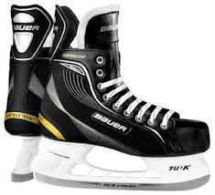 | Skates - make sure your kids are properly fitted for skates. Buying skates is much different than shoes and kids do not wear the same size as their shoe. A proper fit for skates should generally fit 1-1.5 sizes smaller than your street shoes. Toes should barely touch the toe cap, while having no more than 1/2 inch of space in the heel. When finished lacing skates up, skates should feel snug with the foot resting flat on the footbed. A poor fitting skate can create bad habits and breakdown prematurely while holding back skate performance.  (Don’t forget to get them sharpened. And check your child’s blades periodically, if you find a deep nick or burr on the bottom if the blade, it should be sharpened.)
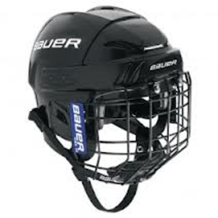 | Helmet - any color will work. Helmet must be HECC and CSA certified helmet, characterized by an approval sticker. A helmet should fit snug yet comfortable to maximize protection. Measurements for Helmet or Mask - To properly fit a helmet, you must measure in inches the circumference the head approx. 1" above the eye brows. This circumference will aid in the proper sizing of the helmet.
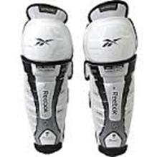 | Shin Guards - to ensure proper fit, make sure that the cap of the shin pad is centered upon the knee cap and that there is no gap between the top of your skates and bottom of the pads. Sizes are based on the measurement from middle of the knee cap to the ankle bone. For a youth player this is usually 7”, 8”, or 9”
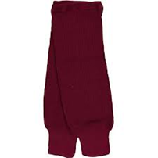 | Hockey socks
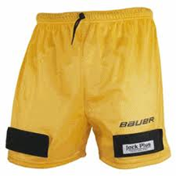 | Supporter/cup – these items are now integrated combo jock/jill “sport short” with Velcro appropriate to hold the socks up.
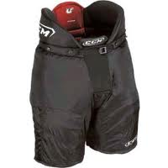 | Hockey Pants  Shorts should fit comfortable while offering full range of motion for the player and protection to the upper thighs. Measurements for shorts - The size of the shorts should correspond to the player's waist size.
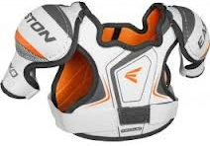 | Shoulder Pads - sizes are based on the length in inches around the chest just below the armpits.
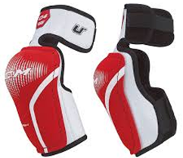 | Elbow Pads
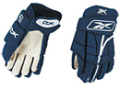 | Gloves - sizes are based on the measurement from finger base to elbow. For a youth player this is usually 8” or 9”  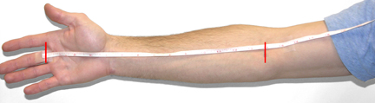
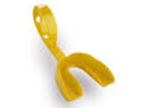 | Mouthguard - that attaches to the helmet mask (so it’s less likely to get lost or fall on the ice) Take special care in selecting this, and trim it as necessary to get a comfortable fit.
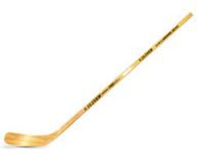 | Stick - A straight blade stick with a youth size shaft is best for little hands. Left or right handed shots are not yet determined at this age, so a straight blade is suggested.  A stick shaft should be cut to the proper length. While standing on skates, place the blade bottom tip between the legs and let the stick shaft come vertically up past the center of the face….touching the tip of the nose. Mark the height at the chin (some experts recommend even lower, slightly above the collar bone) and cut the stick shaft at that point.
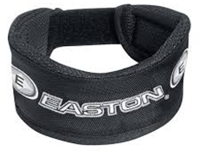 | Neck guard - while not mandated, is recommended

